* Sort the Year of On-Set in an ascending order. See Excel named “YearOfOnset”, Sheet “YearOfOnset”
* Calculate the Yearly mean of age of on-set from 1952 to 2020. See Sheet “YearlyMeanAgeOfOnSet”
* Import the data into R
* Plot Year against MeanAgeOnset

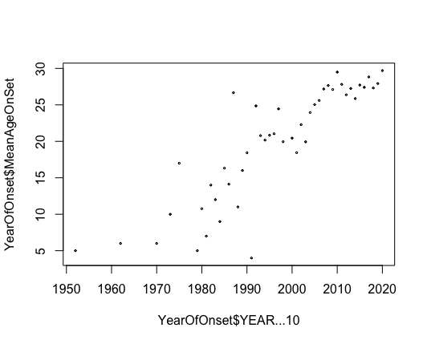

* Fit a linear regression model

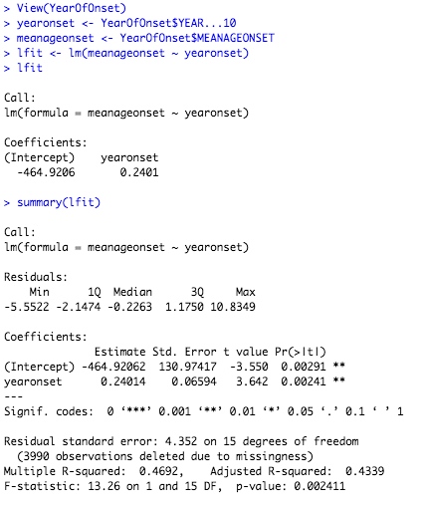

* Multiple R-squared = 0.4692, which indicates a bad fit
* Fit a segmented regression model

